Ideation Phase
Empathize & Discover

Date | 01 april 2026
Team ID
Project Name | Earth-meet(video calling app)
Maximum Marks | 4 Marks

Empathy Map Canvas: 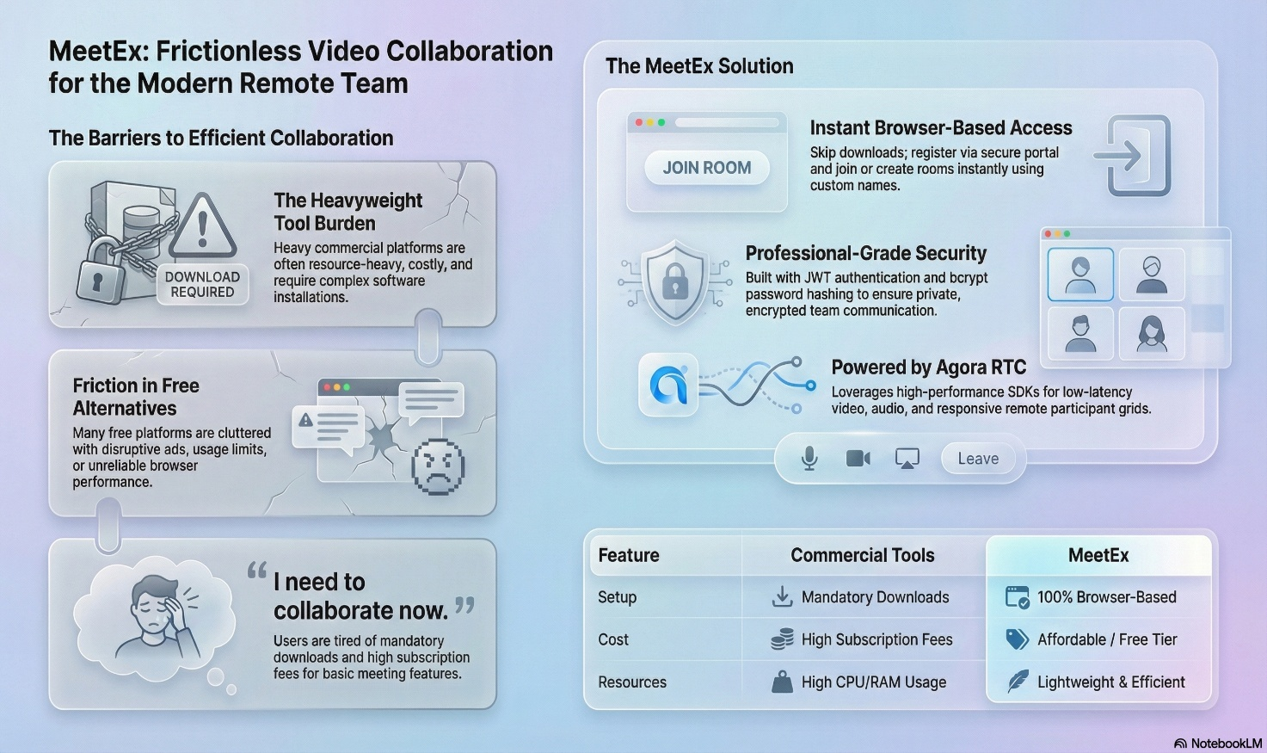
. Who are we empathising with?
- User: Remote workers, students, and educators who are tech-savvy but busy.
- Goal: They need to conduct secure, real-time video meetings without the friction of high costs or complex software setups.
2. What do they SEE?
- Market Landscape: Heavyweight commercial tools like Zoom that are often costly and resource-heavy.
- Environment: Team communication delays happening over email or Slack.
- Alternatives: Free platforms that are cluttered with ads and usage limits or browser-based apps that lack reliability.
3. What do they SAY?
- "I need to collaborate now without downloading extra software".
- "I'm tired of paying high subscription fees for basic meeting features".
- "I want to be able to join a room fast, with no hassle".
- "I need to be able to mute my mic or stop my camera easily during calls".
4. What do they DO?
- Actions: They search for affordable or free web-based tools and register quickly using email credentials.
- Engagement: They create custom room names, share codes with colleagues, and toggle their media tracks (camera/mic) during sessions.
- Workflow: They log in via secure portals and expect to leave sessions cleanly to save system resources.
5. What do they HEAR?
- Feedback: Colleagues complaining about technical glitches or lag during important meetings.
- Demands: Increased pressure from management or institutions for secure and private communication platforms.
- Recommendations: Peers talking about lightweight, "glassmorphism-styled" modern alternatives that work directly in the browser.
6. What do they THINK and FEEL?
- Pains (Before):
  - Frustrated by subscription limits and hidden costs.
  - Anxious about poor connections or technical barriers like mandatory downloads.
  - Overwhelmed by the number of complex tools required for simple tasks.
- Gains (After):
  - Confident and productive when the technology "just works".
  - Relieved by a simple, secure, and lightweight interface like Earth-meet.
  - Satisfied with a premium, seamless experience that enables efficient teamwork.

